Ideation Phase
Define the Problem Statements
Date | 05 October 2026
Team ID | SWTID-2026-4458
Project Name | Import Data using Transform Maps (Spreadsheet)
Team Leader | Monika B
Team Members | D Keerthana, Chandhana S, Vemalaraju Poojitha, Subasri R
Maximum Marks | 2 Marks
Customer Problem Statement Template:
Create a problem statement to understand your customer's point of view. The Customer Problem Statement template helps you focus on what matters to create experiences people will love.
A well-articulated customer problem statement allows you and your team to find the ideal solution for the challenges your customers face. Throughout the process, you’ll also be able to empathize with your customers, which helps you better understand how they perceive your product or service.
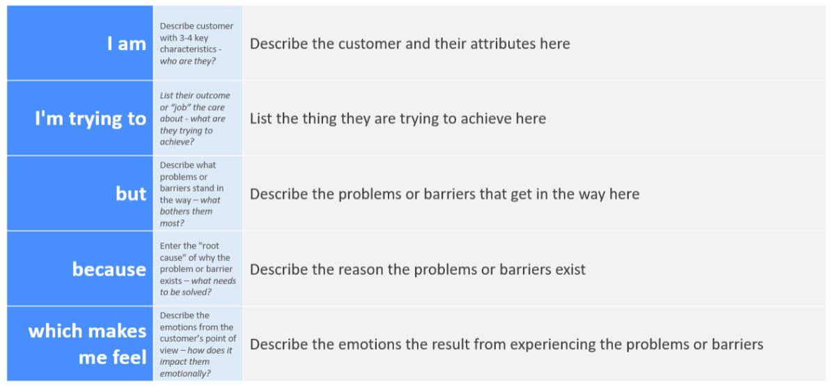
Reference: https://miro.com/templates/customer-problem-statement/
Example:

Problem Statement (PS) | I am (Customer) | I’m trying to | But | Because | Which makes me feel
PS-1 | A ServiceNow Administrator / Data Owner | load employee data received in an Excel spreadsheet into ServiceNow in bulk, quickly and accurately | entering employee records one by one is slow, and typing mistakes or duplicate employees creep in | there is no automated way to stage the spreadsheet data, map its columns to the Employee table and check it before it reaches the live table | frustrated and worried, because I have to redo records and fix errors by hand
PS-2 | A ServiceNow Developer / Platform Administrator | keep the Employee table accurate by updating existing employees and adding only new ones, using Employee ID as the unique identifier | without a coalesce field every import creates duplicate employee records, and I cannot easily check what was inserted or updated | the spreadsheet fields are not mapped through an Import Set and Transform Map, so there is no matching on Employee ID and no transform history to review | concerned and unsure, because poor data quality affects reports and trust in the employee data

